## Laboratory 2: Oscilloscope

## Môn: Hệ thống số (TN)

## Lớp: L01

## Nhóm: 7

## GVHD: Kiều Đỗ Nguyên Bình

## Thành viên: Lê Đức Huy 1810166

## Nguyễn Gia Huy 1810173

## Huỳnh Thiên Trình 1810615

## Lê Bá Thông 1810555

## Lê Duy Bình 51204735

# **III. Exercises**

**Exercice 1**: Measurement Propagation Delay

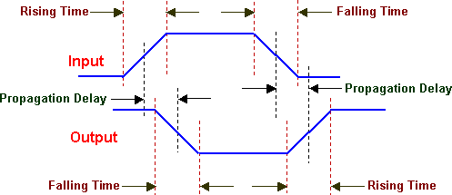

Figure 1: Propagation Delay

Use oscilloscope for measure propagation delay of these following ICs and fill these gaps below:

7400: 4.4 ns

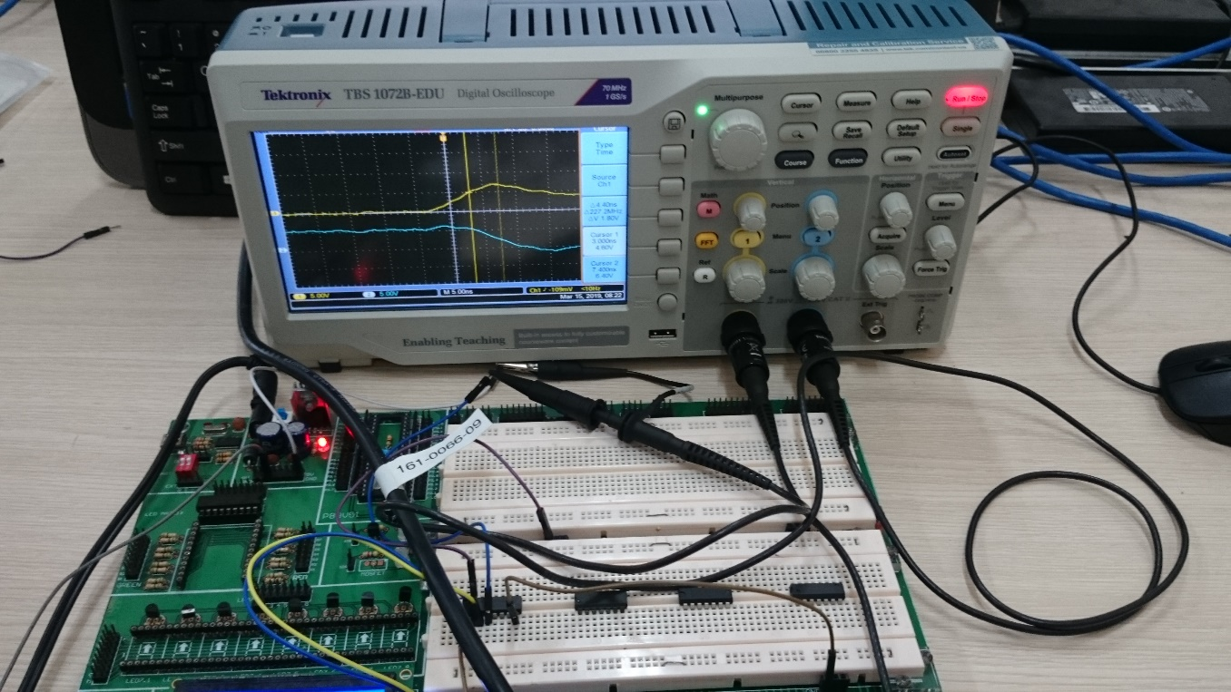

7404: 4.6 ns

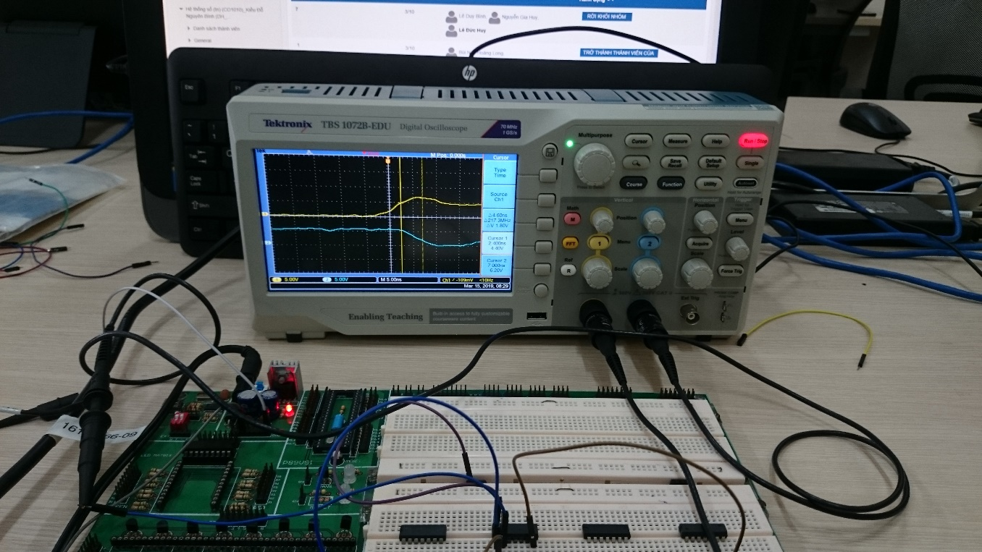

7408: 8.8 ns

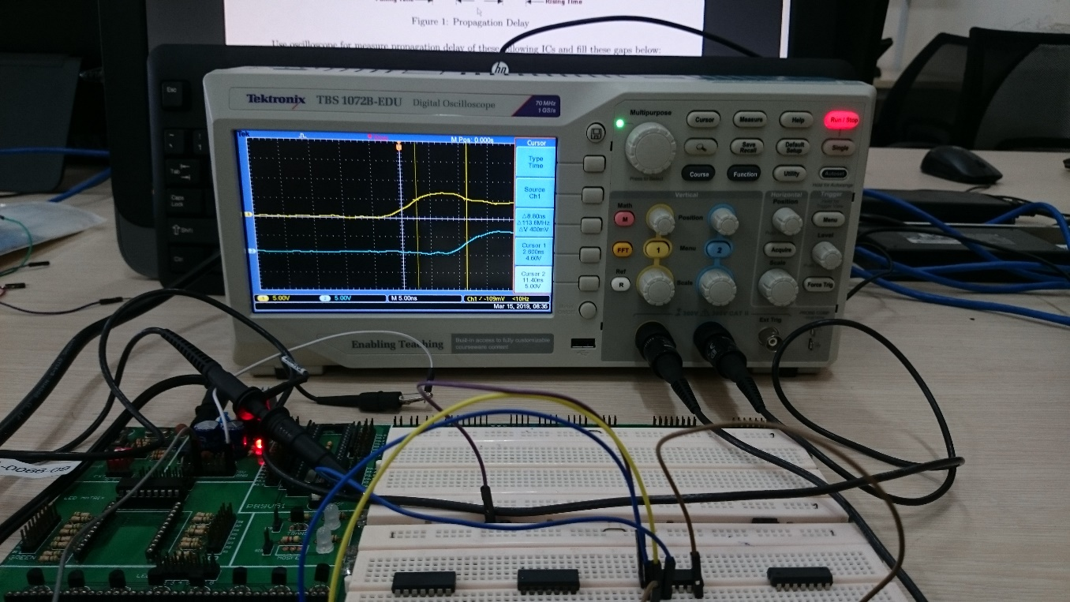

7432: 8.2 ns

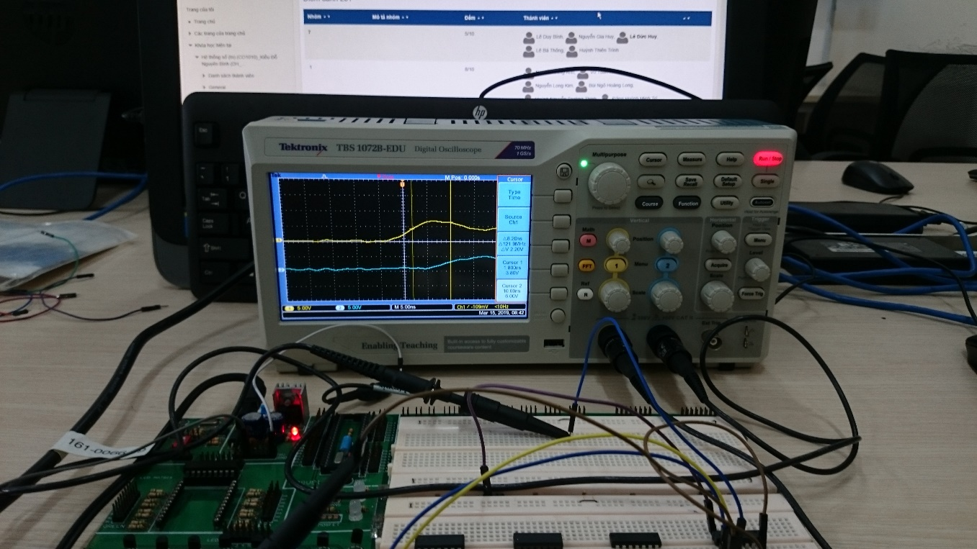

**Exercice 2**: Egde Detector Circuit

Implement 1 on 3 circuits below and test it by using oscilloscope:

1. Use IC 7404 and 7408 to implement edge detector circuit.
2. Use IC 7404 and 7432 to implement edge detector circuit.
3. Use only IC 7400 to implement edge detector circuit. (+1 bonus)

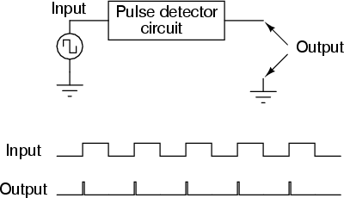

Figure 2: How edge detector circuit works

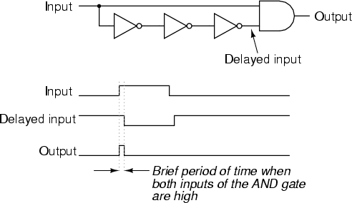

Figure 3: Sample edge detector circuit design

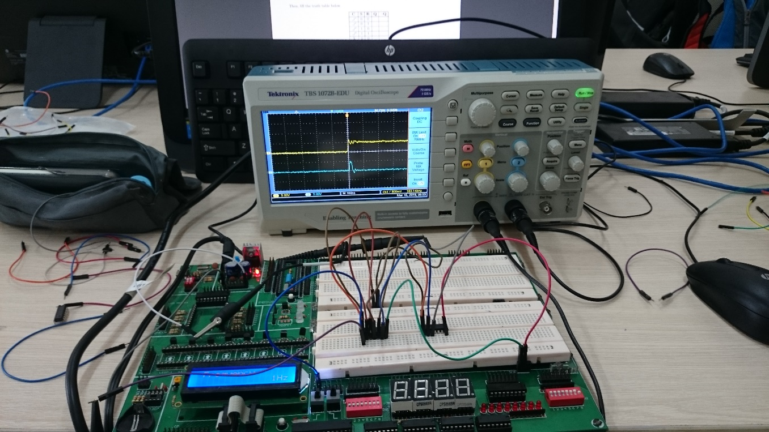

**Exercice 3**: (Extend Exercises) Implement the circuit below using edge detector circuit in Ex2.

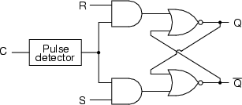

Figure 4: SR-Latch Design

Then, fill the truth table below.

|  |  |  |  |  |
| --- | --- | --- | --- | --- |
| **C** | **S** | **R** | **Q** | *¬***Q** |
|  | 0 | 0 | NC | NC |
|  | 0 | 1 | 0 | 1 |
|  | 1 | 0 | 1 | 0 |
|  | 1 | 1 | Invalid | Invalid |
| X | 0 | 0 | X | X |
| X | 0 | 1 | X | X |
| X | 1 | 0 | X | X |
| X | 1 | 1 | X | X |

Table 1: SR-Latch Truth Table

Test circuit using Oscilloscope (Channel 1 for C signal, Channel 2 for Q signal) and describe the function of this circuit.

